Ex. No. : 01 Date:
Register No. : 221701007 Name : AMRITHA A

GUI Components
Aim
Develop an application to change the font and color of the text and display a toast message when the user presses the button.
Procedure:
Step 1 : File → New Project
Provide the application name and click “Next”.
Step 2 : Select the target Android devices
Select the minimum SDK to run the application. Click “Next”.
Step 3 : Choose the activity for the application
By default, choose “Blank Activity”. Click “Next”.
Step 4 : Enter activity name and click “Finish”.
Step 5 : Edit the program
Design the UI in activity_main.xml and write Kotlin code in
MainActivity.kt
Step 6 : Run the application
Two ways to run the application:
- Running through emulator
- Running through mobile device

AndroidManifest.xml

<?xml version="1.0" encoding="utf-8"?>
<manifest xmlns:android="http://schemas.android.com/apk/res/android"
xmlns:tools="http://schemas.android.com/tools">

<application
android:allowBackup="true"
android:dataExtractionRules="@xml/data_extraction_rules"
android:fullBackupContent="@xml/backup_rules"
android:icon="@mipmap/ic_launcher"
android:label="@string/app_name"
android:roundIcon="@mipmap/ic_launcher_round"
android:supportsRtl="true"
android:theme="@style/Theme.GUI"
tools:targetApi="31">
<activity
android:name=".MainActivity"
android:exported="true">
<intent-filter>
<action android:name="android.intent.action.MAIN" />

<category android:name="android.intent.category.LAUNCHER" />
</intent-filter>
</activity>
</application>

</manifest>

Activity_main.xml

<?xml version="1.0" encoding="utf-8"?>
<LinearLayout xmlns:android="http://schemas.android.com/apk/res/android"
xmlns:tools="http://schemas.android.com/tools"
android:id="@+id/rootLayout"
android:layout_width="match_parent"
android:layout_height="match_parent"
android:orientation="vertical"
android:padding="16dp"
android:background="#6200EA"
tools:context=".MainActivity">

<TextView
android:id="@+id/appTitleTextView"
android:layout_width="match_parent"
android:layout_height="wrap_content"
android:text="Text Customization"
android:textSize="24sp"
android:textColor="#FFFFFF"
android:textStyle="bold"
android:gravity="center"
android:layout_marginBottom="32dp"/>

<TextView
android:id="@+id/collegeNameTextView"
android:layout_width="match_parent"
android:layout_height="wrap_content"
android:text="Rajalakshmi Engineering College"
android:textSize="20sp"
android:textColor="#FFFFFF"
android:gravity="center"
android:padding="16dp"
android:layout_marginBottom="32dp"/>

<Button
android:id="@+id/changeFontSizeButton"
android:layout_width="match_parent"
android:layout_height="wrap_content"
android:text="Change Font Size"
android:layout_marginBottom="16dp"
android:backgroundTint="#8A2BE2"/>

<Button
android:id="@+id/changeFontColorButton"
android:layout_width="match_parent"
android:layout_height="wrap_content"
android:text="Change Font Color"
android:layout_marginBottom="16dp"
android:backgroundTint="#8A2BE2"/>

<Button
android:id="@+id/changeBackgroundButton"
android:layout_width="match_parent"
android:layout_height="wrap_content"
android:text="Change Background Color"
android:layout_marginBottom="16dp"
android:backgroundTint="#8A2BE2"/>

</LinearLayout>

MainActivity.kt

package com.example.gui
import android.graphics.Color
import android.graphics.Typeface
import android.os.Bundle
import android.view.View
import android.widget.Button
import android.widget.TextView
import android.widget.Toast
import android.appcompat.app.AppCompatActivity

class MainActivity : AppCompatActivity() {
private lateinit var collegeNameTextView: TextView

override fun onCreate(savedInstanceState: Bundle?) {
super.onCreate(savedInstanceState)
setContentView(R.layout.activity_main)

collegeNameTextView = findViewById(R.id.collegeNameTextView)

// Set initial values
collegeNameTextView.text = "Rajalakshmi Engineering College"

// Setup buttons
setupChangeFontSizeButton()
setupChangeFontColorButton()
setupChangeBackgroundColorButton()
}

private fun setupChangeFontSizeButton() {
val button = findViewById<Button>(R.id.changeFontSizeButton)
val fontSizes = arrayOf(16f, 20f, 24f, 28f, 32f)
var currentIndex = 0

button.setOnClickListener {
currentIndex = (currentIndex + 1) % fontSizes.size
collegeNameTextView.textSize = fontSizes[currentIndex]
showToast("Font size changed to ${fontSizes[currentIndex]}sp")
}
}

private fun setupChangeFontColorButton() {
val button = findViewById<Button>(R.id.changeFontColorButton)
val colors = arrayOf(
Color.BLACK,
Color.RED,
Color.BLUE,
Color.GREEN,
Color.MAGENTA
)
val colorNames = arrayOf("Black", "Red", "Blue", "Green", "Magenta")
var currentIndex = 0

button.setOnClickListener {
currentIndex = (currentIndex + 1) % colors.size
collegeNameTextView.setTextColor(colors[currentIndex])
showToast("Text color changed to ${colorNames[currentIndex]}")
}
}

private fun setupChangeBackgroundColorButton() {
val button = findViewById<Button>(R.id.changeBackgroundButton)
val colors = arrayOf(
Color.WHITE,
Color.LTGRAY,
Color.CYAN,
Color.YELLOW,
Color.parseColor("#3F51B5") // Indigo
)
val colorNames = arrayOf("White", "Light Gray", "Cyan", "Yellow", "Indigo")
var currentIndex = 0

// Get the root layout
val rootLayout = findViewById<View>(R.id.rootLayout)

button.setOnClickListener {
currentIndex = (currentIndex + 1) % colors.size

// Change the background color of the entire layout
rootLayout.setBackgroundColor(colors[currentIndex])

// Change text colors to ensure readability
if (colors[currentIndex] == Color.YELLOW || colors[currentIndex] == Color.WHITE || colors[currentIndex] == Color.LTGRAY) {
collegeNameTextView.setTextColor(Color.BLACK)
findViewById<TextView>(R.id.appTitleTextView).setTextColor(Color.BLACK)
} else {
collegeNameTextView.setTextColor(Color.WHITE)
findViewById<TextView>(R.id.appTitleTextView).setTextColor(Color.WHITE)
}

showToast("Background changed to ${colorNames[currentIndex]}")
}
}

private fun showToast(message: String) {
Toast.makeText(this, message, Toast.LENGTH_SHORT).show()
}
}

Output

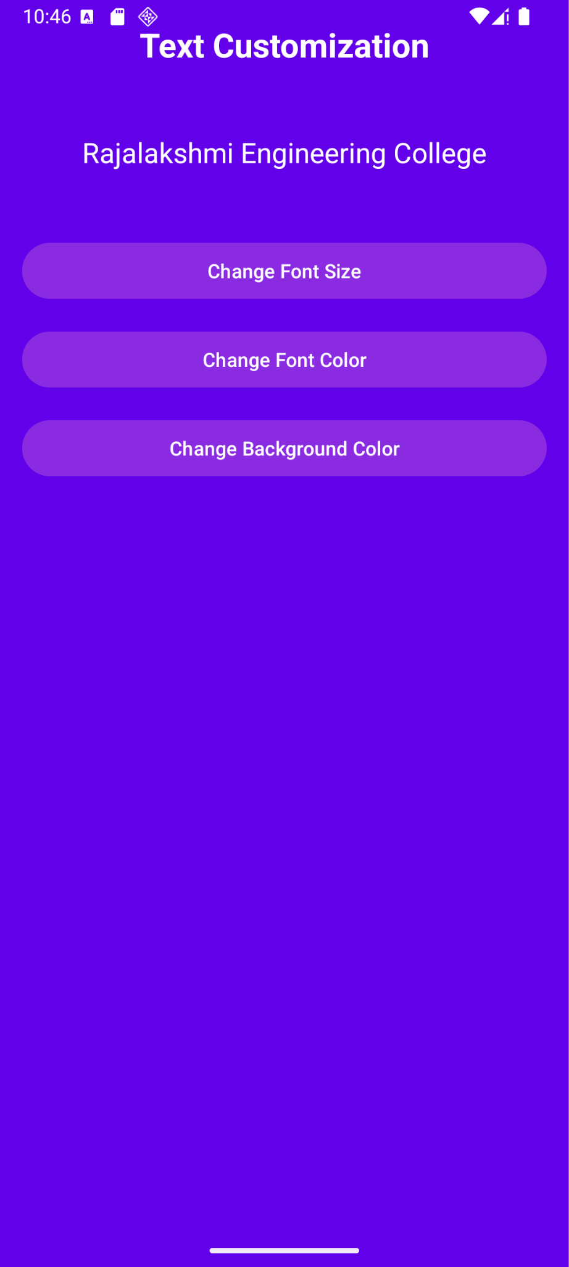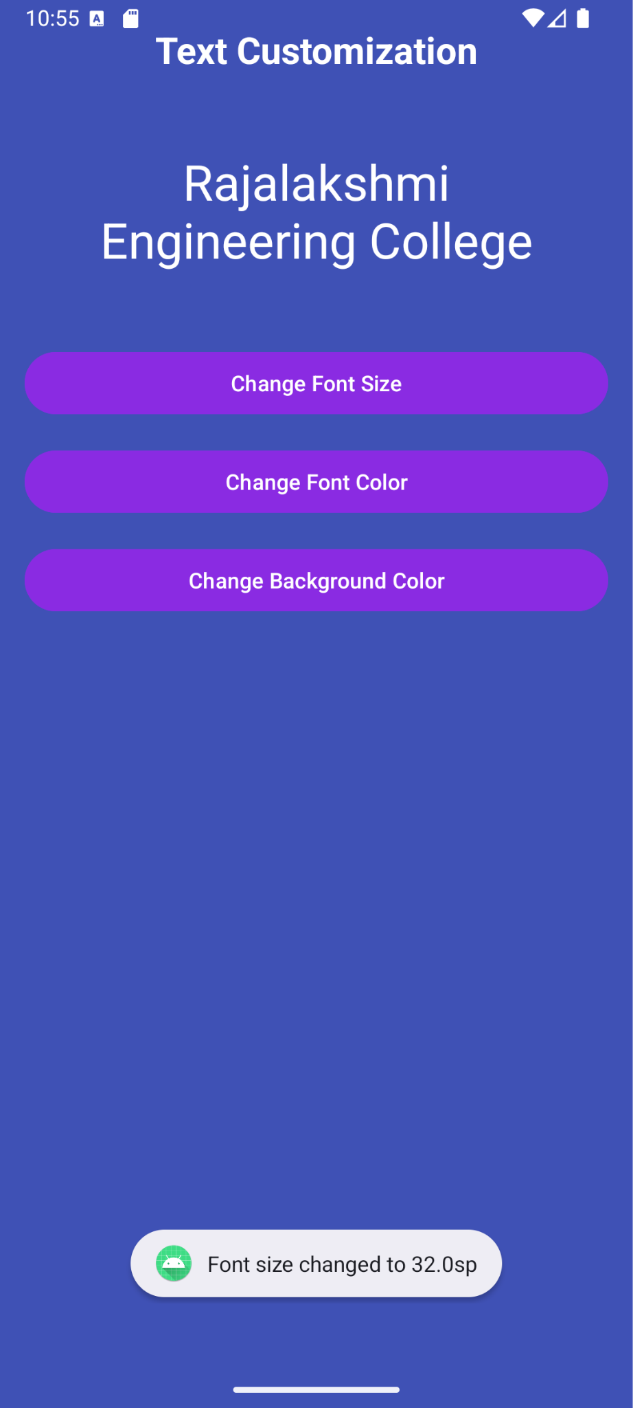
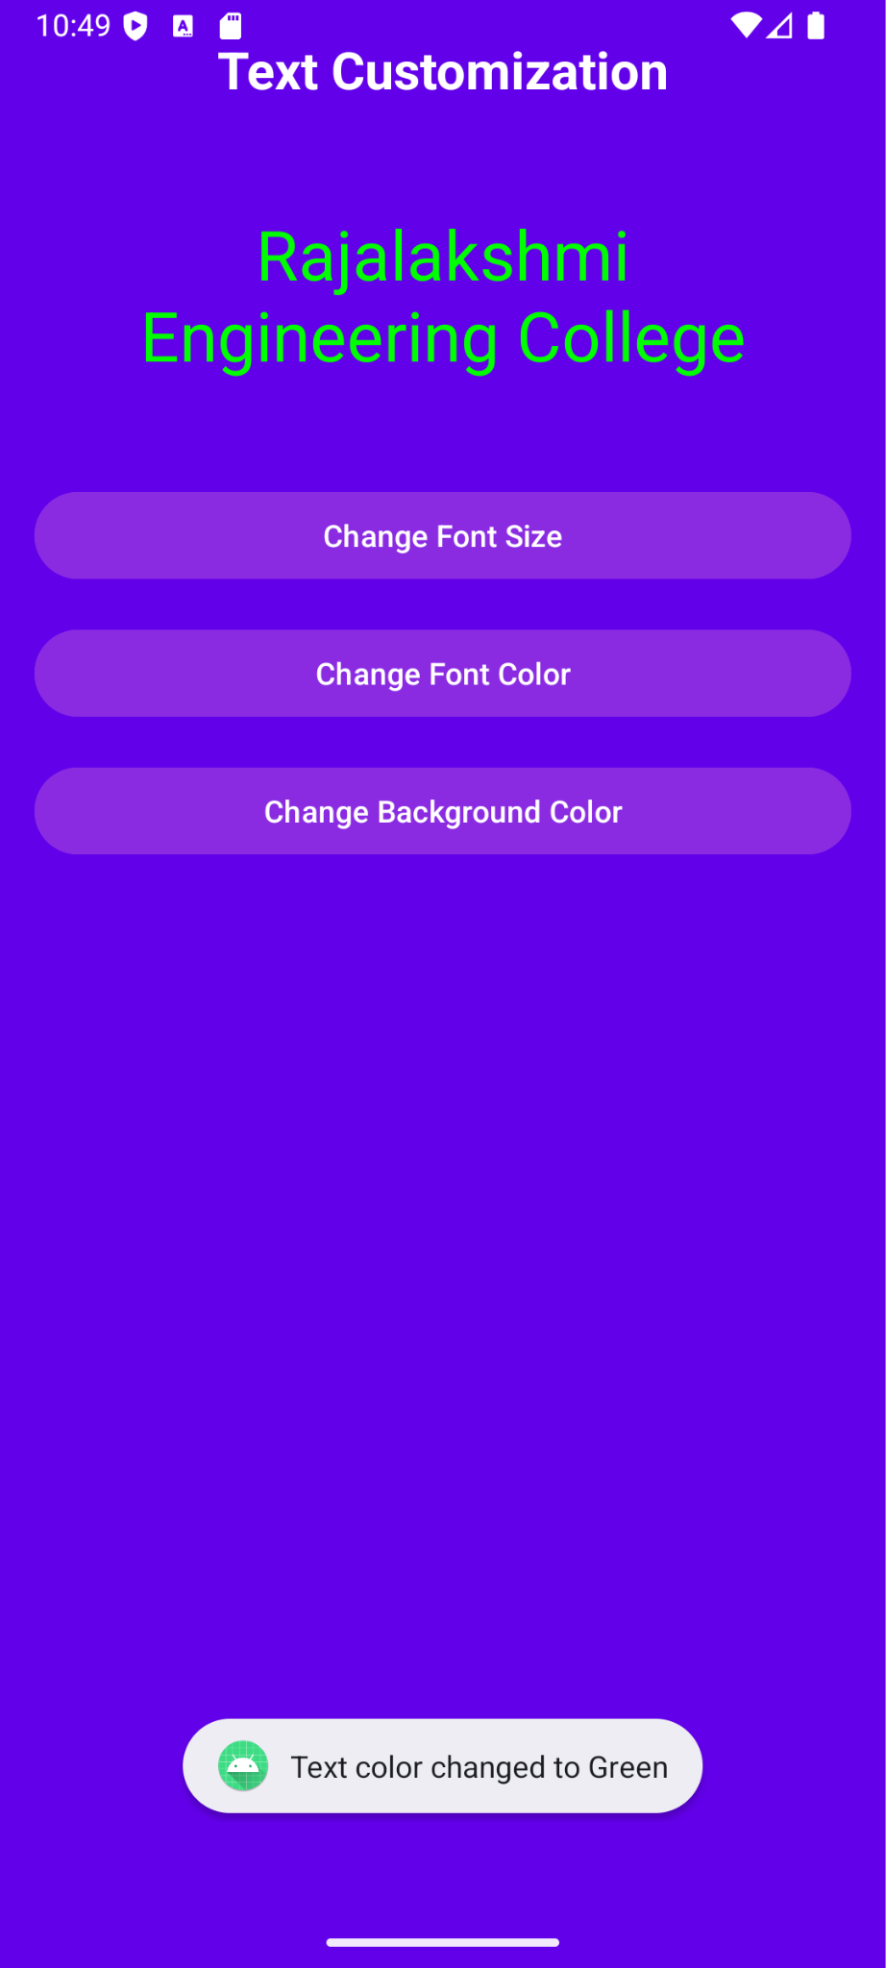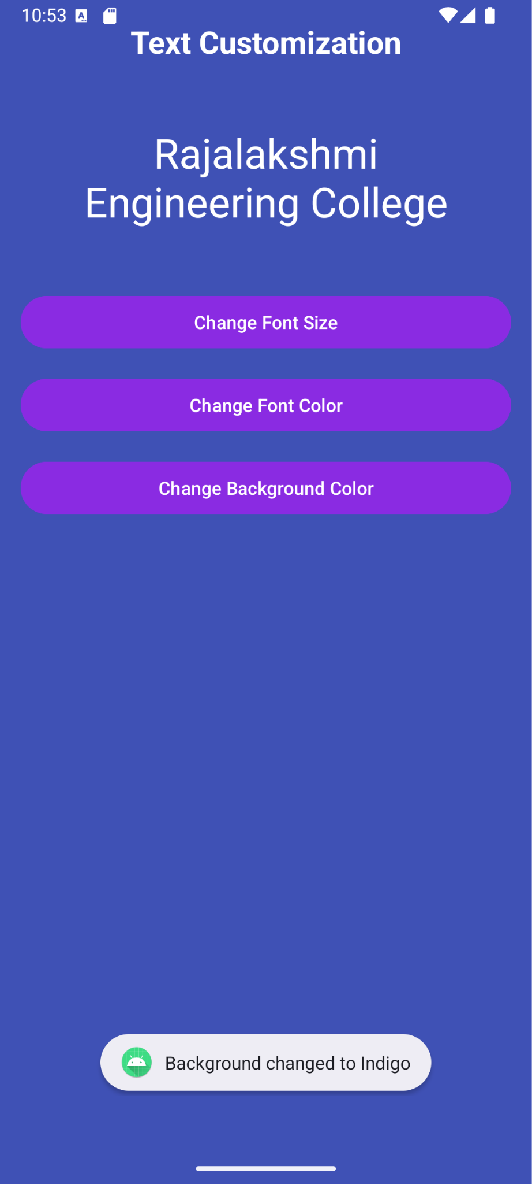

Result:
The GUI application successfully displays a user interface and performs the intended functions when run on an emulator or mobile device.

